Additional Learning Needs
A Guide for Parents and Carers



Independent Parent Support
SNAP Cymru
Tel: 0808 801 0608
Web: www.snapcymru.org

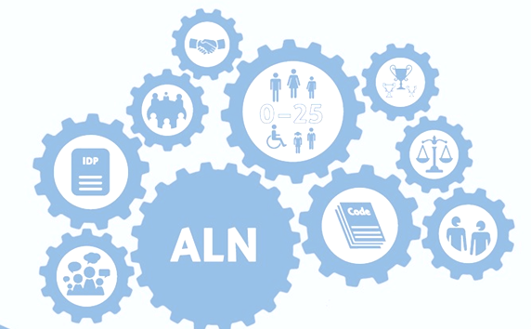

Additional Learning Needs (ALN)
Children or young people have an additional learning need when:
- they have a significant difficulty or disability that means they need targeted and sustained support;
- they find it much harder to learn than children or young people of the same age nationally;
- they have a disability that means they cannot use their local school or college.
Children or young people identified as having ALN require additional learning provision.
Additional learning provision (ALP) is support which is additional to that provided to the majority of children or young people of the same age.

Person Centred Planning
Places the learners’ views, wishes and feelings at the heart of the process of planning the support required to enable them to learn effectively and achieve their full potential.

Roles in School and at Home
ALNCo: A designated person who will have responsibility for co-ordinating provision for learners with ALN. That person (or persons) will be known as an additional learning needs co-ordinator, or ALNCo.

Class Teacher: Has responsibility for the day to day process of supporting every learner with ALN in their class.

Teaching Assistants: Support pupils in achieving their targets through activities set by the class teacher or outside agencies.
Parents/Carers: To support their child and school to achieve their targets through activities and play.

Outside Agencies: Relevant services that will support a pupil or student’s ALP as required. Some learners with ALN will need the support of external agencies and professionals.

ALN Process
The possibility that a child has ALN may be brought to the attention of the school by a staff member, parent or the child themselves. In the first instance this should be discussed with the class teacher who will follow the processes set out by the school and Additional Learning Needs Code for Wales 2021.

The School will
- designate a person to be responsible for co-ordinating the actions required to make that decision, which may include in school assessments or referrals to outside agencies and, if required, prepare an Individual Development Plan (IDP)
- record the date on which the concern was brought to their attention
- record a summary of how the possibility that the child has ALN has been brought to their attention
- notify the child and the child’s parents that the school is deciding whether the child has ALN, with an indication of the likely timescale for the process.
- consider offering an initial meeting with the child and the child’s parent, to discuss the process.
- provide parents with information and advice about ALN and the ALN system, including the rights of appeal.
The school must make the decision and give the notification promptly and before 35 school days from it being brought to the attention of the school. The school need not comply with the requirement if it is impractical to do so due to circumstances beyond its control.

Where it is decided that a child does not have ALN, their parent should be informed of that decision and the reasons for that decision, as well as an outline of what action the school will undertake in consideration of the child’s needs (which are not ALN).

Where it is decided that a child has ALN, the school will determine what level of additional learning provision the child needs and prepare a Passport and Learning Plan to outline what support the child will need, which may include additional resources, small group intervention or specialised support and where required an Individual Development Plan.

Individual Development Plans (IDPs)
An IDP is a single plan which will be developed through using a person-centred planning approach. All IDP’s will include an Action Plan plus the evidence for the actions. It will encourage key-working where needed and use flexible processes.
The IDP will include the advice of a range of professionals supporting the child or young person (where relevant).
IDPs will be reviewed annually or when anything significant changes for the child or young person.
Individual development plans (IDPs) will replace the existing variety of statutory and non-statutory plans for learners of compulsory school age and below, and those over compulsory school age in school or further education.
Local authorities will normally only prepare and maintain an IDP in instances where the child or young person’s needs are more severe or complex. Ordinarily IDPs will be the responsibility of the maintained school or further education institution.

Person Centred Review
It is all about:
- listening and understanding your child’s views and wishes.
- supporting your child to think about what is important to them and for them.
- helping your child to think what’s working and not working.
- making sure that your child gets the best support from everyone. For example, you, the school and other professionals.
When a review is due you will receive an invite to a meeting at the school and a parental contribution form to be completed and returned prior to the meeting. This will give you the opportunity to think about what you would like to discuss and what your contribution will be.
- What do you like and admire about your child? (Happy, kind, determined)
- What is important to your child? (Activities, friends)
- What is important for your child? (Health, behaviour intervention, additional support)
- What is working well/not working? (What is going well or not for your child?)
- Questions (Do you have any questions?)

Disagreement Resolution and Rights of Appeal
Whenever possible, disagreements will be dealt with as quickly as possible with the school and the key people involved.
An appeal is when you request that a decision be changed.
Independent support groups will be able to listen and help if there are disagreements which cannot be resolved.
Children, young people, parents and carers have the right to appeal decisions made by the school and the Local Authority about the child or young person’s additional learning needs or additional learning provision.


