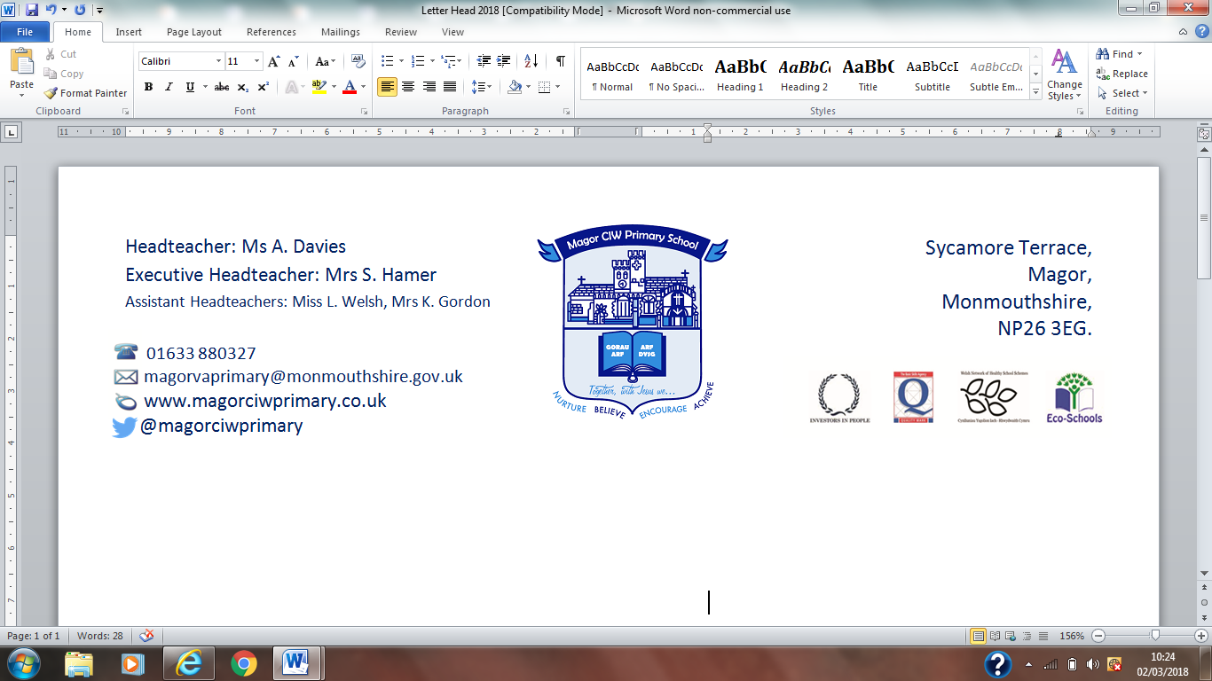
Ysgol Gynradd Magwyr Eglwsig
17th September, 2018
Parent Consultations (Reception to Year 6 Classes)
You are invited to school to see your child(ren)’s work and discuss progress with their teacher. The consultations are for 10 minutes per child. For the benefit of your child, teachers need to be able to speak to you in confidence, without your child present. Consultations will take place in the school hall between the end of the school day and 5:30pm.
The dates for the forthcoming consultations are:
Monday 15th October, Tuesday 16th October and Wednesday 17th October
Please indicate your preferred date below. Preferred days will be allocated on a first come, first served basis. We allocate appointments to siblings on the same day. You will be notified of your times as soon as possible. We are unable to offer a choice of time slots.

Please return the slip below (one per child) to the class teacher by Thursday 20th September.

Thank you for your cooperation.



Parents Consultation – Date Request Slip

Name of child: ____________________________________________ Class: ______________

Preferred Date: Please tick one or more that you can attend

Monday 15th October |  | Tuesday 16th October |  | Wednesday 17th October

Name/s of siblings and their classes: _______________________________________________________

Parents Consultation Confirmation Slip (To be completed by class teachers only)

Name of Child:_________________________________________ Class_________________
An appointment has been made for you at:

_____________pm on Monday 15th October / Tuesday 16th October / Wednesday 17th October
Appointments have been allocated on a first come, first served basis.

