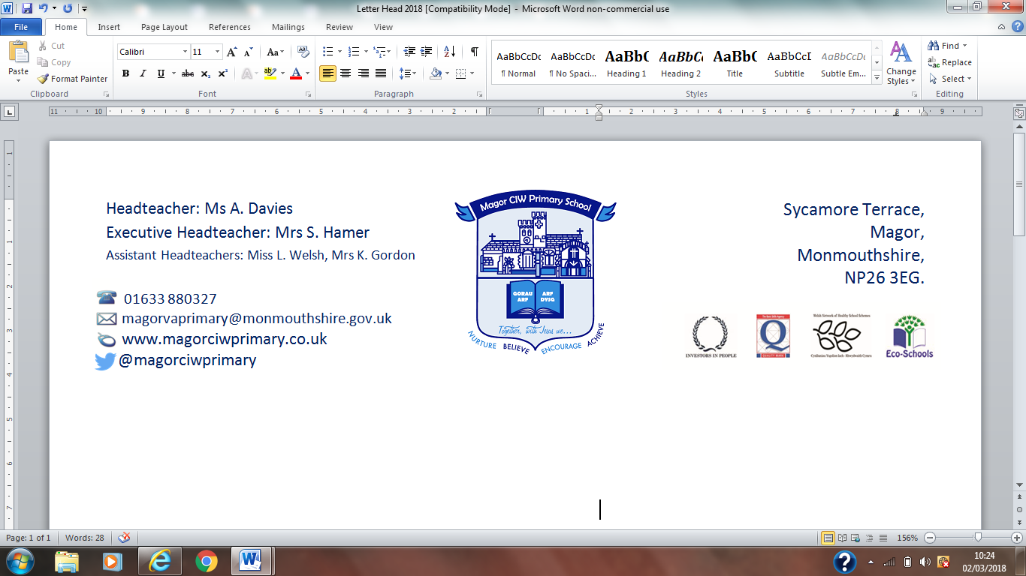
Ysgol Gynradd Eglwysig Magwyr

22nd October 2018
Dear Parent / Guardian,
We would like to remind you that as listed on the school website calendar, the school photographer is visiting school on Wednesday 24th October to take both individual photographs and sibling groups for all nursery and school pupils.

Photographs will be taken during the school day, with the exception of those of you who have preschool aged children. If you would like a photograph to include these younger brothers and sisters, these will take place from 8:30 am and you will need to arrive at the main school reception. These will be completed as quickly as possible.

When you receive the proofs of the photographs, please return any orders promptly.
Thank you for your support
Best Wishes
Mrs K Wilding
(Teacher and PTFA member)

