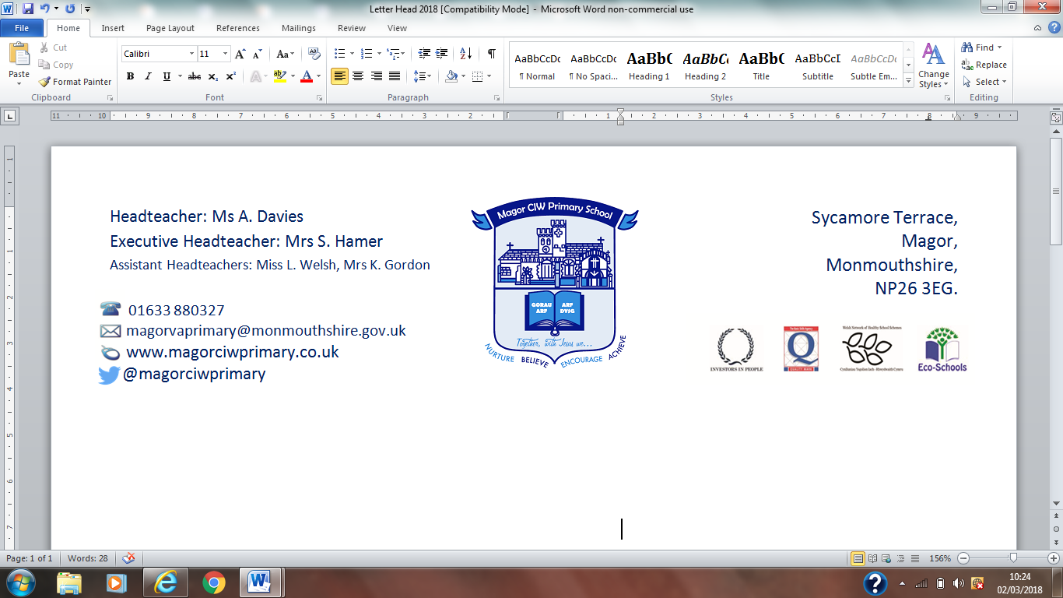
Ysgol Gynradd Eglwysig Magwyr
22 November 2018,

Dear Parent/Carer,

Christmas Lunch Monday 17th December 2018

Christmas lunch will be served in school on Monday 17th December:

- Roast turkey or vegetarian roast, roast & boiled potatoes, seasonal vegetables, roast parsnip, chipolata sausage, stuffing and gravy
- Christmas biscuits & ice cream
- A glass of fruit squash

Please note jacket potatoes and pizza will not be available on Monday 17th December.
Pizza will be served on Wednesday 19th December instead of the usual Wednesday roast dinner.

The cook has asked for numbers as she needs to place an accurate order with the suppliers.

Please complete the slip below to indicate whether your child will be having Christmas lunch on this day or home sandwiches and return it to school no later than Monday 3rd December.

Thank you for your co-operation.

Please return by Monday 3rd December 2018

My child_________________________________________ Class___________________
Would like Christmas lunch □ Will be bringing home sandwiches □

on Monday 17th December 2018.

