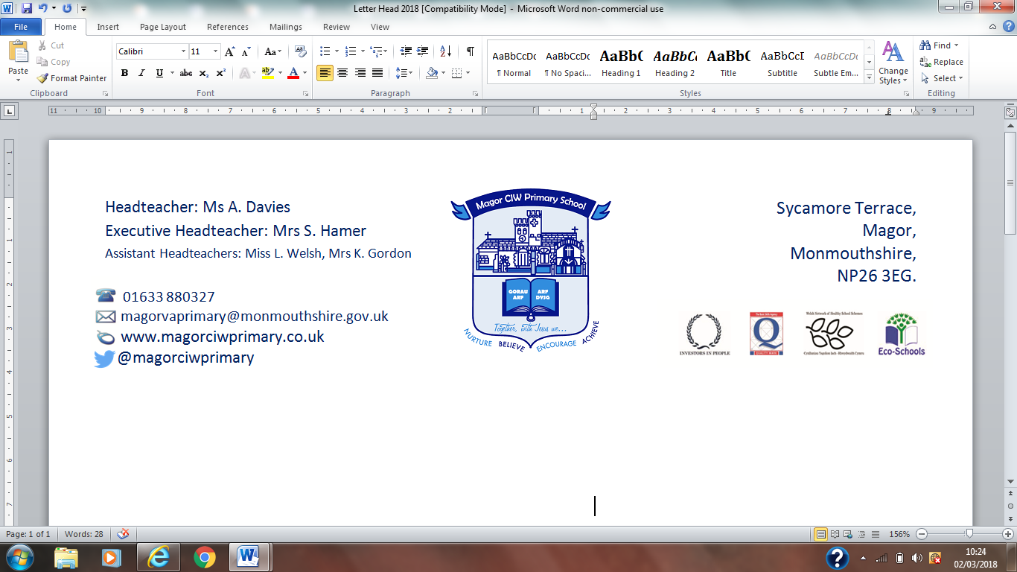
Ysgol Gynradd Eglwysig Magwyr

20th December 2018,

Dear Parents/Carers,
IMPORTANT – SCHOOL MEALS PARENTPAY BOOKING AND MENU SELECTION
From Tuesday 8th January 2019 school meals must be booked on ParentPay in advance. This booking system has already been introduced in other Monmouthshire schools and has been very successful. Classroom dinner registers will no longer be taken and the kitchen will therefore only prepare meal choices as ordered on ParentPay.
All school meals must be booked before midnight the night before the meal is required. Meals can be booked daily, weekly, monthly or termly. To do this;
- Login to your ParentPay account
- Select Make meal bookings for a pupil
- Select lunchtime from the Make booking from the drop down menu
- Select the date to view in the week commencing drop down menu
- Select Make or View bookings
- Make the menu selections required.
- Select confirm bookings
- Repeat steps 2-7 for any other children requiring meals.
- Select Pay now and follow the payment process.
School meals currently cost £2.45 per meal. Payment needs to be made at the time of booking meals. They will automatically be cancelled by ParentPay if payment is not received within two hours of making a selection. Free School Meals must still be booked and menu choices selected on ParentPay although no charge is made.
If you need to cancel your meal bookings, go to the bookings page and untick the meals previously ordered. The money will be credited back to your ParentPay school meal account.
If you have not registered on ParentPay yet, please contact the school office and they will provide an activation letter with your username and password. Once you have activated your account, you can change the password to something of your own choice.
If you have already activated your ParentPay account but forgotten your password, you will need to reset your password using the ParentPay link.
Any queries please contact the school office.
Yours sincerely,
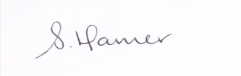
Mrs S Hamer
Executive Headteacher

