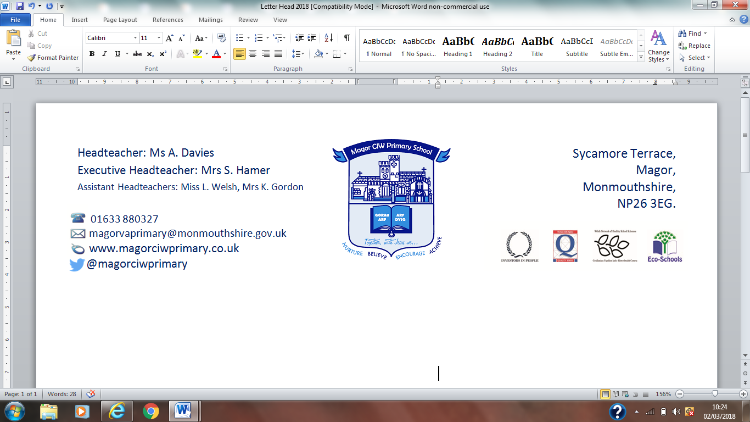
Ysgol Gynradd Eglwysig Magwyr

10th September 2019,

Dear Parents/Carers,

Netball Club for Years 5 & 6
Mrs Johnson will be running a Netball Club. It will be held on Tuesdays from 3.15pm to 4.00pm, starting 17th September 2019. The club is open to years 5 & 6, but places are limited and will be allocated on a first come, first served basis.
Children will need to bring appropriate kit to change in to.
Parents are respectfully reminded that most of the school’s after school clubs are run through the ‘goodwill’ of the staff and are additional to their workload.
At the end of each club session, the children will be brought by the teacher responsible to the main entrance where you can meet them. Please be punctual when collecting your child to avoid distress. If you wish your child to walk home or to Two Tribes after school club by themselves, a parent must inform the school in advance.
If children are unable to attend the club at any point, please inform the school in advance, by letter or telephone. If, for any reason, the club has to be cancelled, the school will try to give children and parents advance notice. If parents cannot be contacted, the children will remain safely in school.
If you would like your child to participate in Netball Club, please submit your consent and emergency contact details via your ParentPay account. There is not a charge for this club.
Best Wishes
Mrs S Hamer
Headteacher

