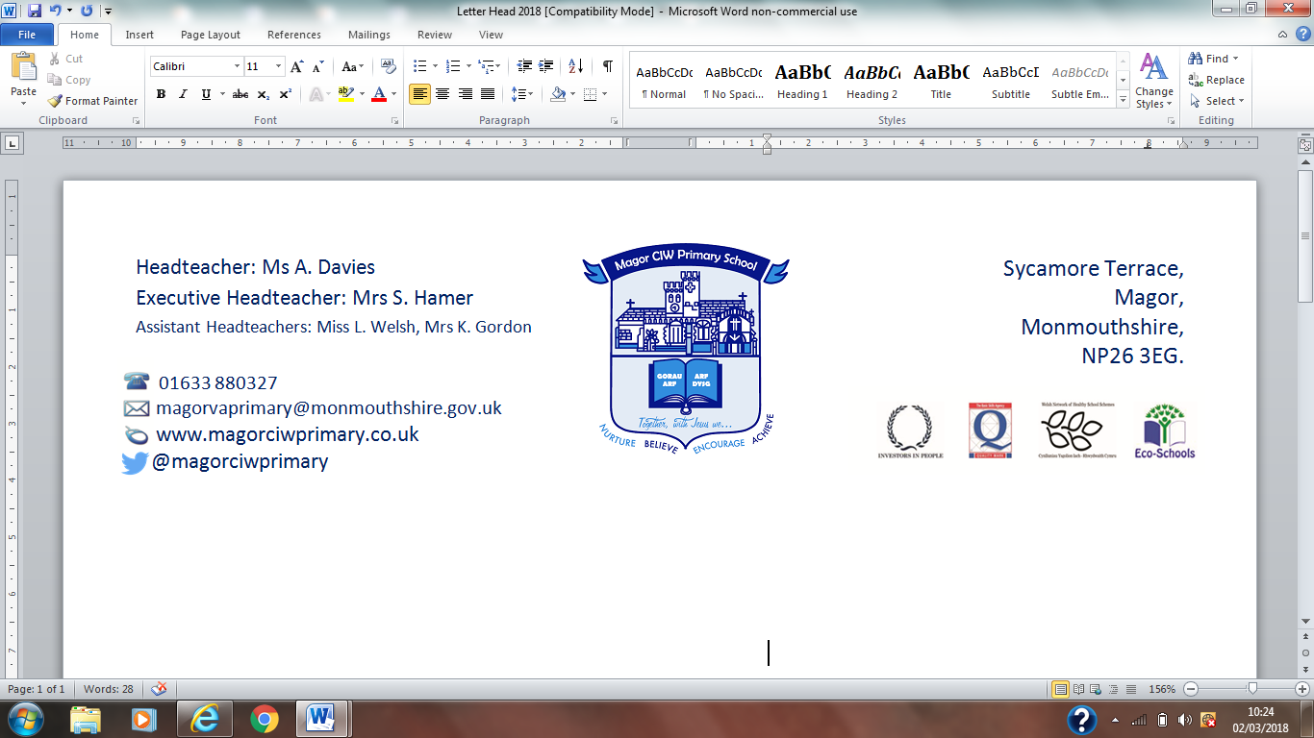
Ysgol Gynradd Eglwysig Magwyr

23rd September 2019,

Dear Parents/Carers,

Outdoor Champions for Years 4, 5 & 6
Mrs John will be running an Outdoor Champions Club. It will be held on Mondays from 3.15pm to 4.15pm, starting 30th September 2019. The club is open to years 4, 5 & 6, but places are limited and will be allocated on a first come, first served basis.
Children will need to bring coats and wellingtons.
Parents are respectfully reminded that most of the school’s after school clubs are run through the ‘goodwill’ of the staff and are additional to their workload.
At the end of each club session, the children will be brought by the teacher responsible to the main entrance where you can meet them. Please be punctual when collecting your child to avoid distress. If you wish your child to walk home or to Two Tribes after school club by themselves, a parent must inform the school in advance.
If children are unable to attend the club at any point, please inform the school in advance, by letter or telephone. If, for any reason, the club has to be cancelled, the school will try to give children and parents advance notice. If parents cannot be contacted, the children will remain safely in school.
If you would like your child to participate in Outdoor Champions Club, please submit your consent and emergency contact details via your ParentPay account, no later than the day before the start date. There is not a charge for this club.
Best Wishes
Mrs S Hamer
Headteacher

