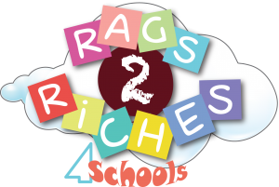
MAGOR PRIMARY SCHOOL COLLECTION DAY IS FRIDAY 6th DECEMBER. RAGS2RICHES BAGS WILL BE SENT HOME AT THE END OF NOVEMBER.
Rags 2 Riches 4 Schools is an easy, efficient way for your school to earn some much-needed cash and, as a real bonus, it is a 100% efficient recycling process.
Whether you just cleaned out your wardrobe, your kids have outgrown their clothes, or you want to raise money for your local school or charity, why not consider getting cash for your clothes? It’ll help the environment too, since they won’t get chucked in the landfills.
Take a look at what we collect in the list below and have fun packing!



